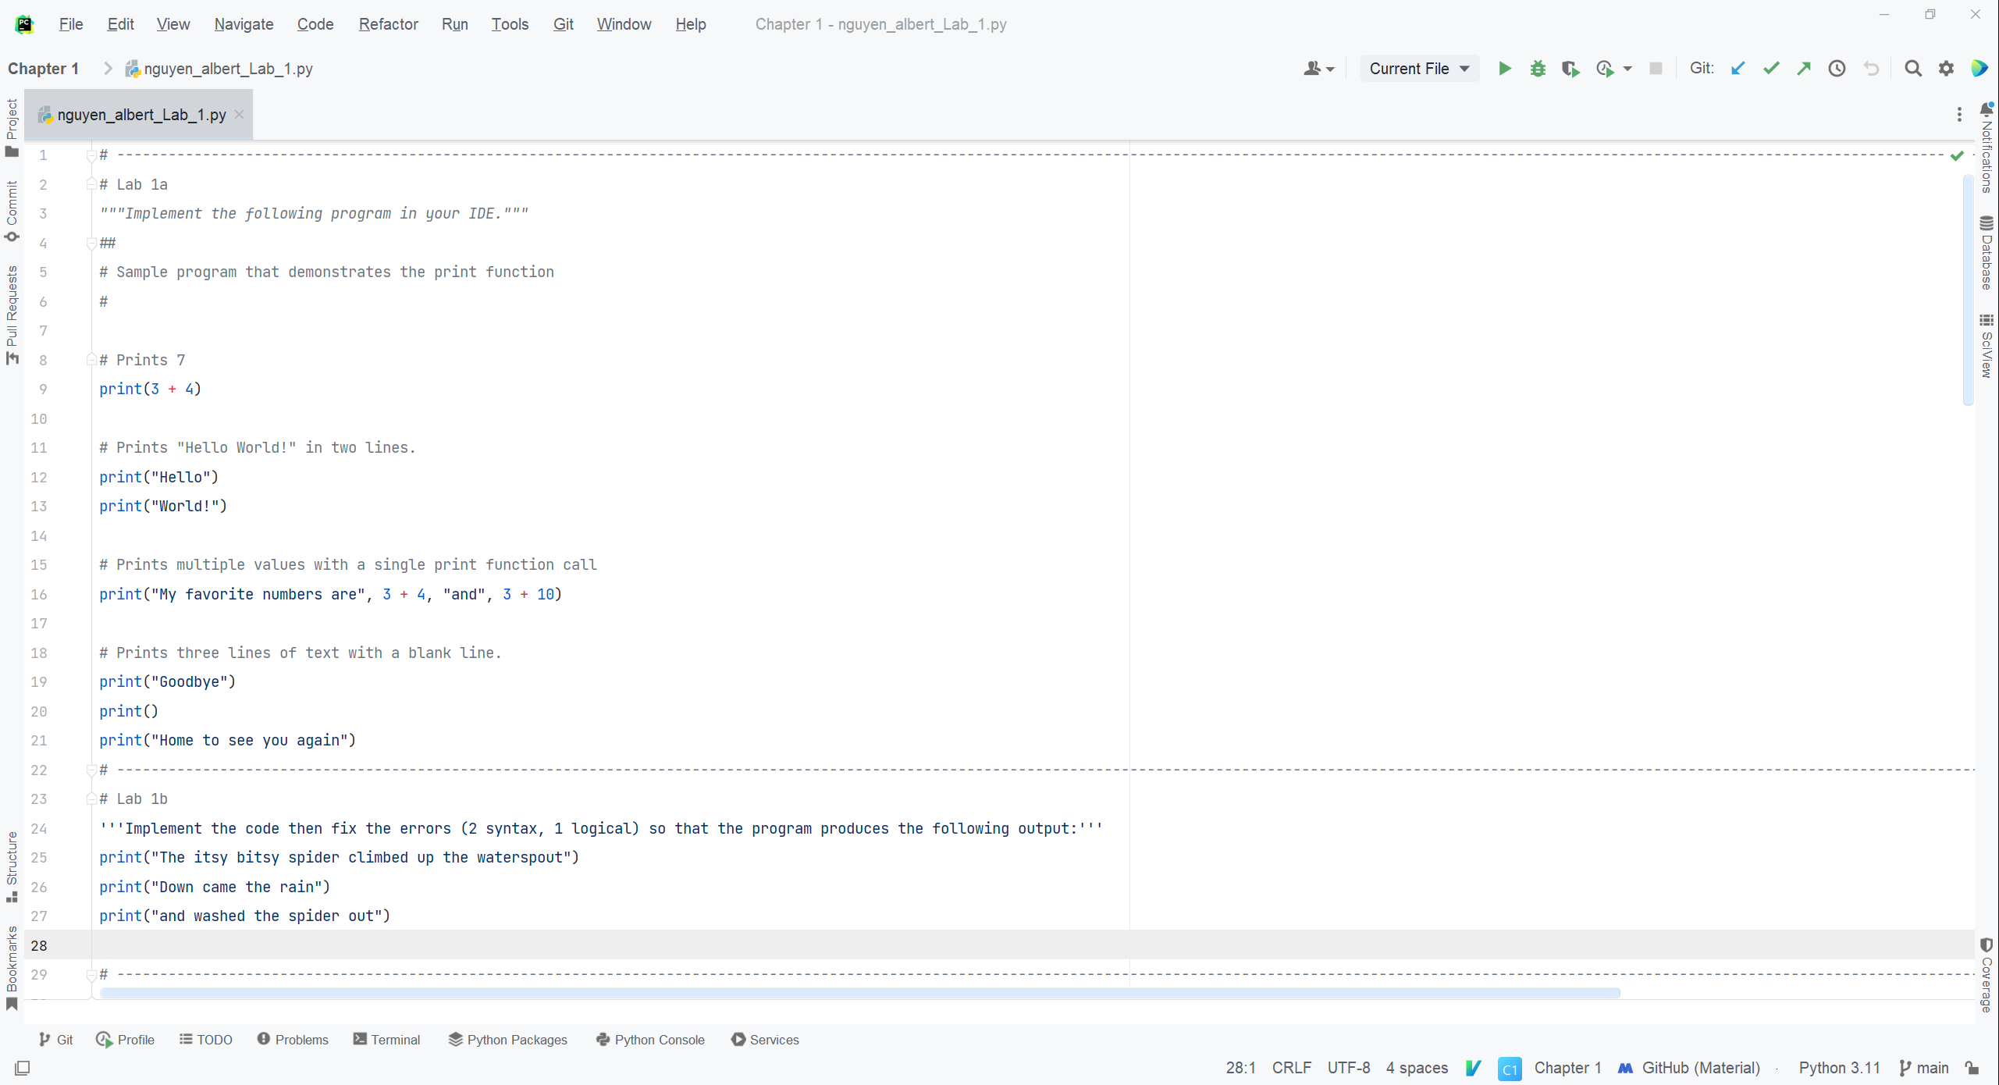

A&B_Code -

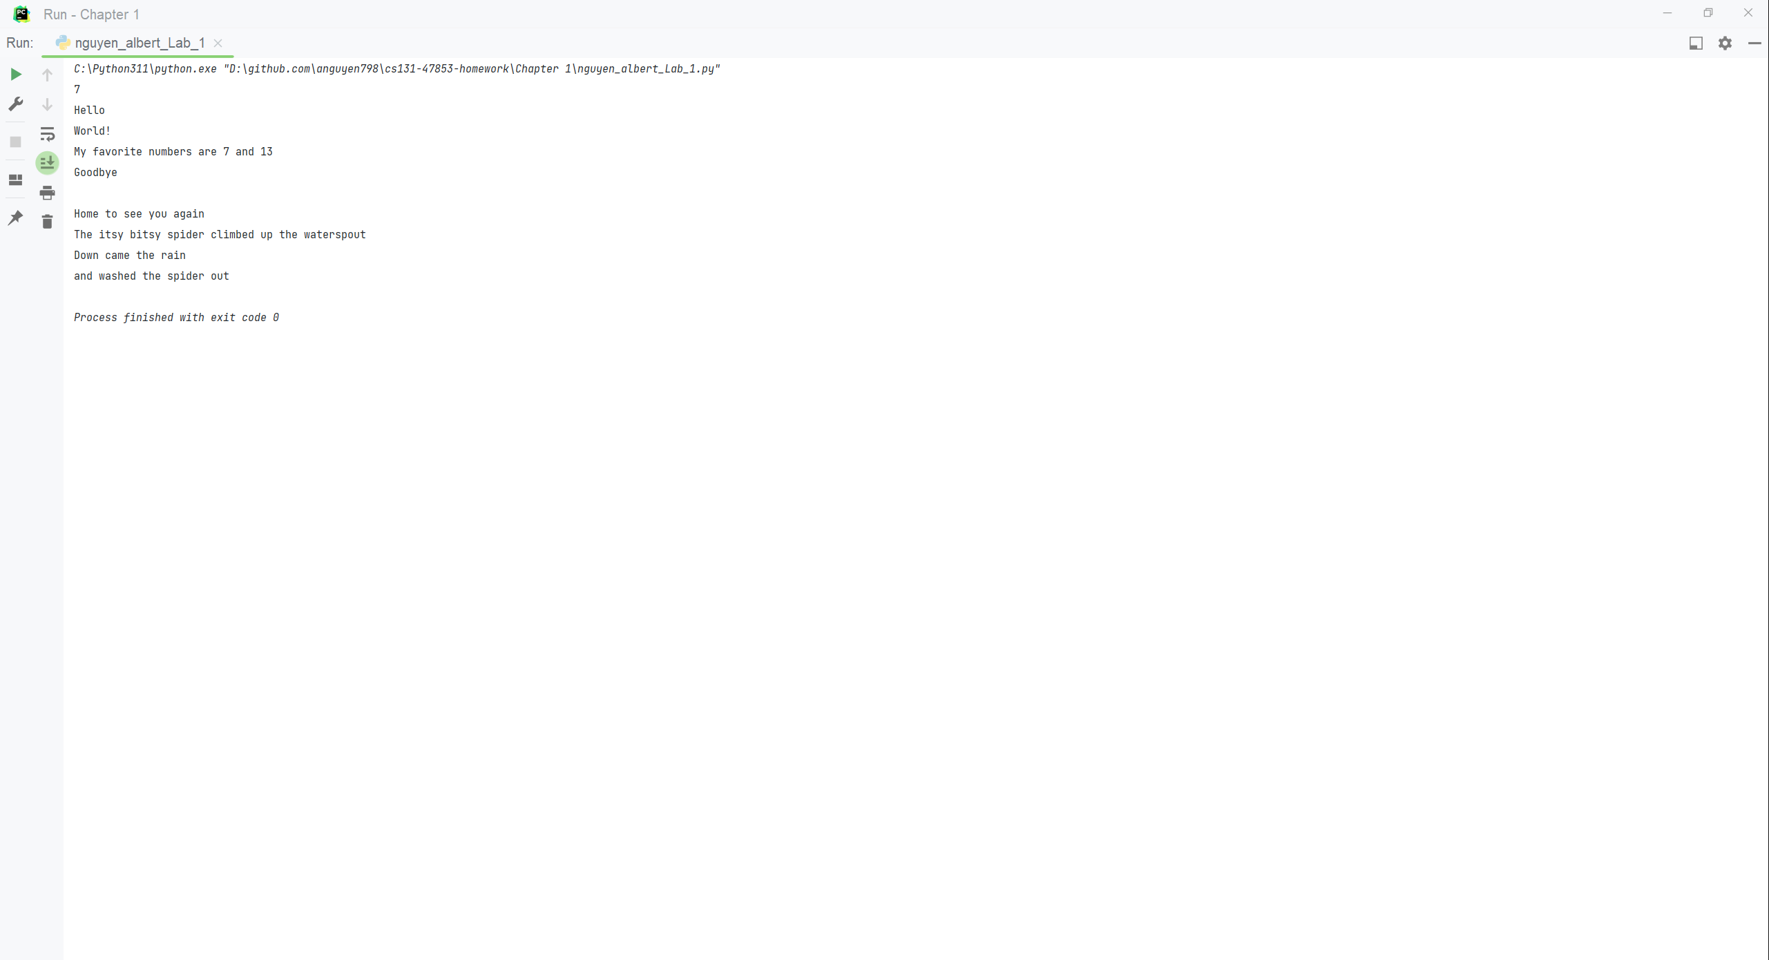

A&B_Consle

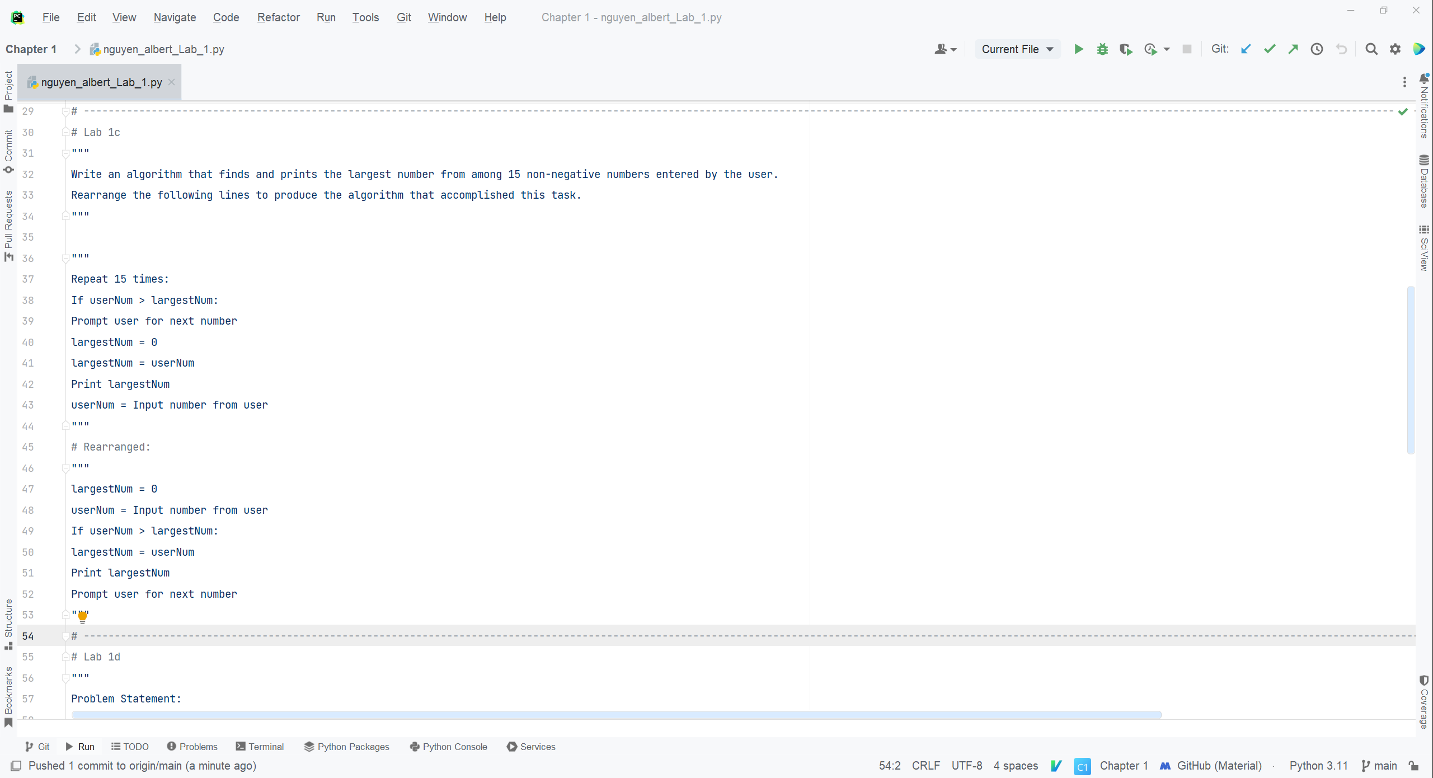

C_Code

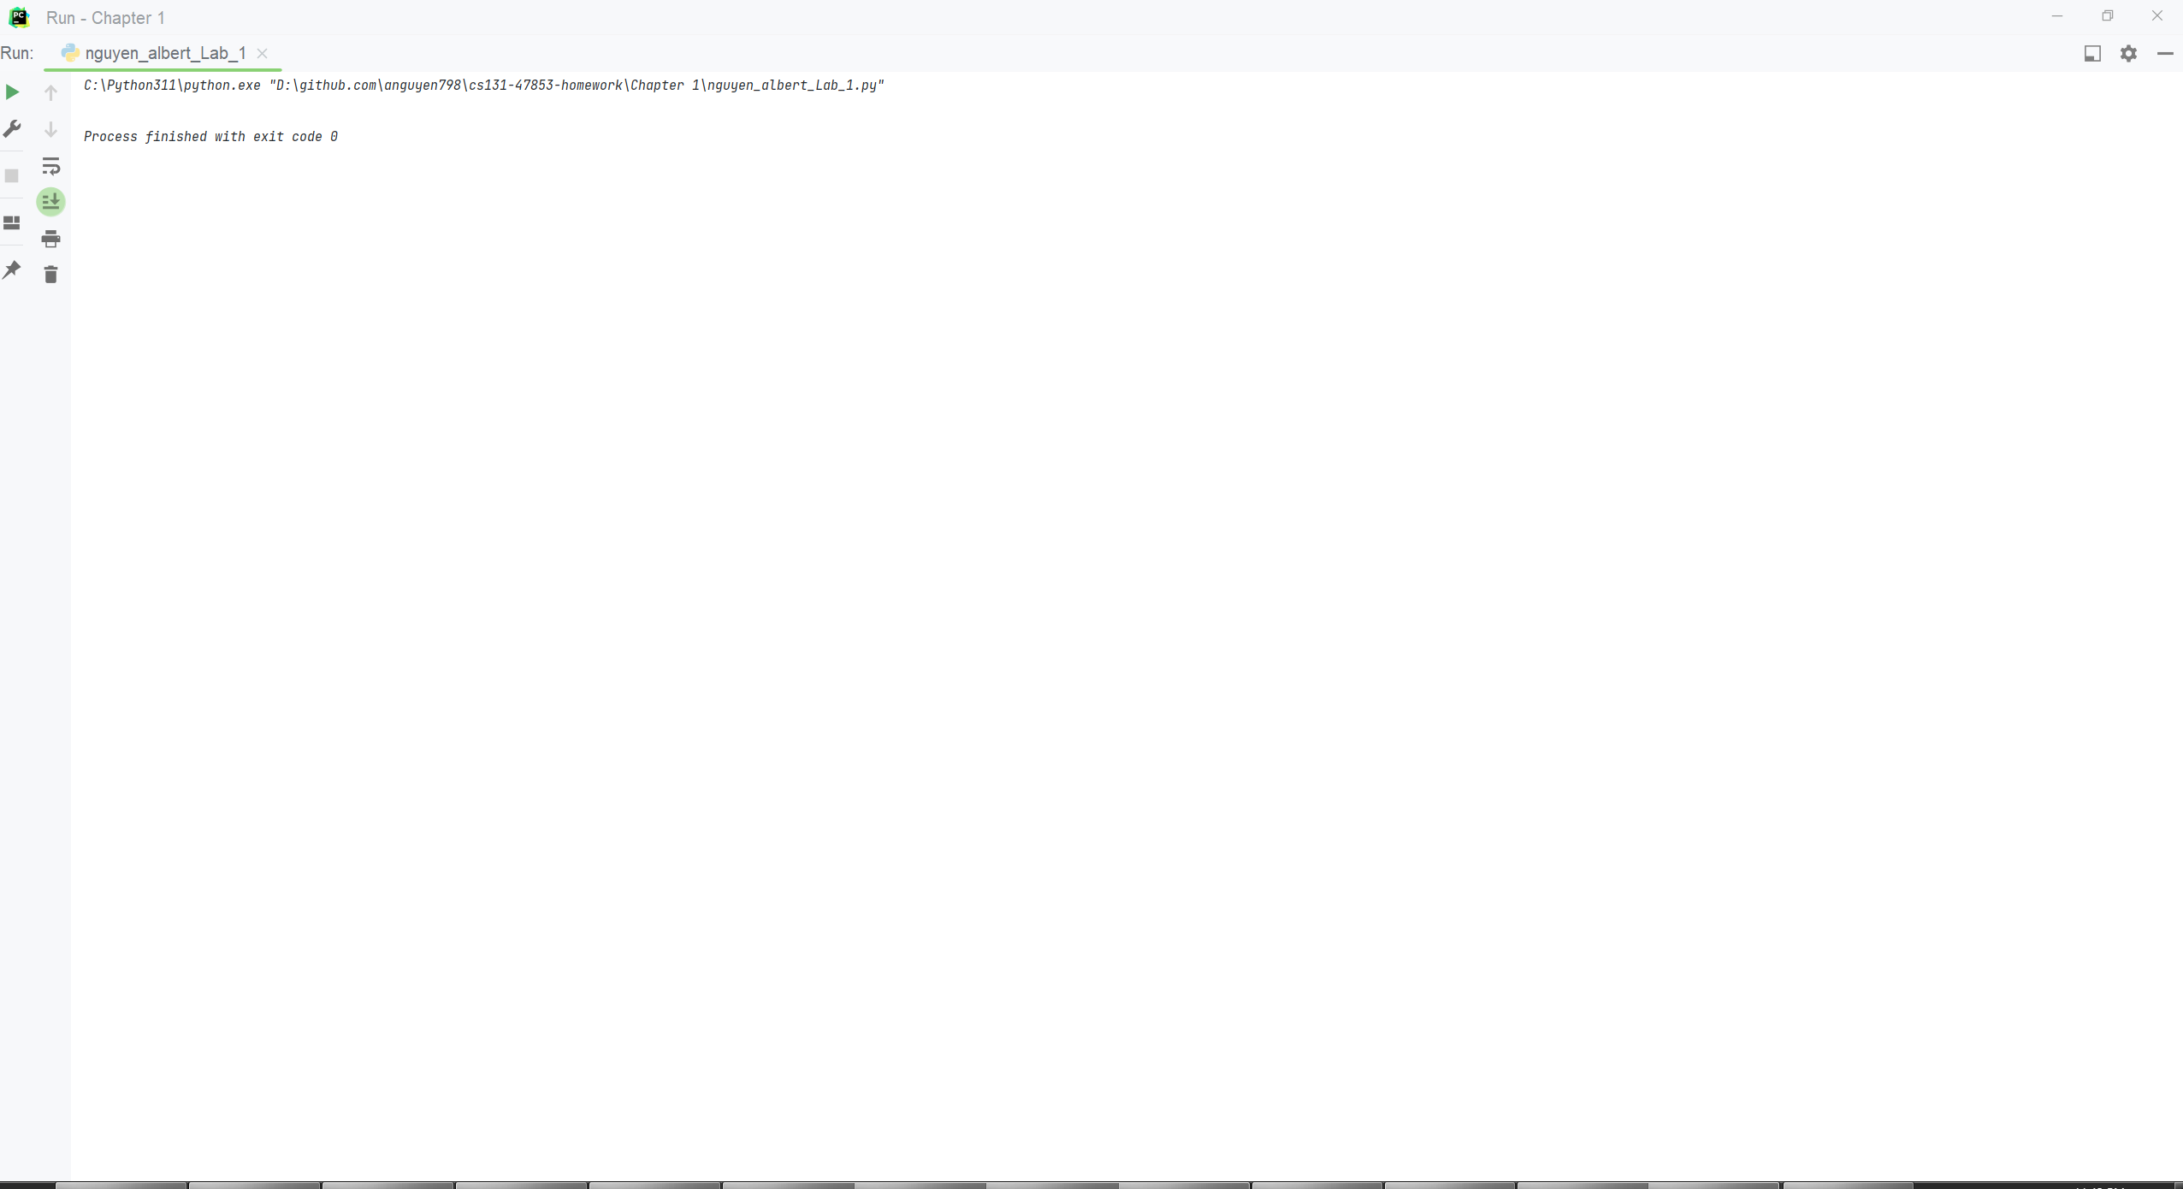

C_Console

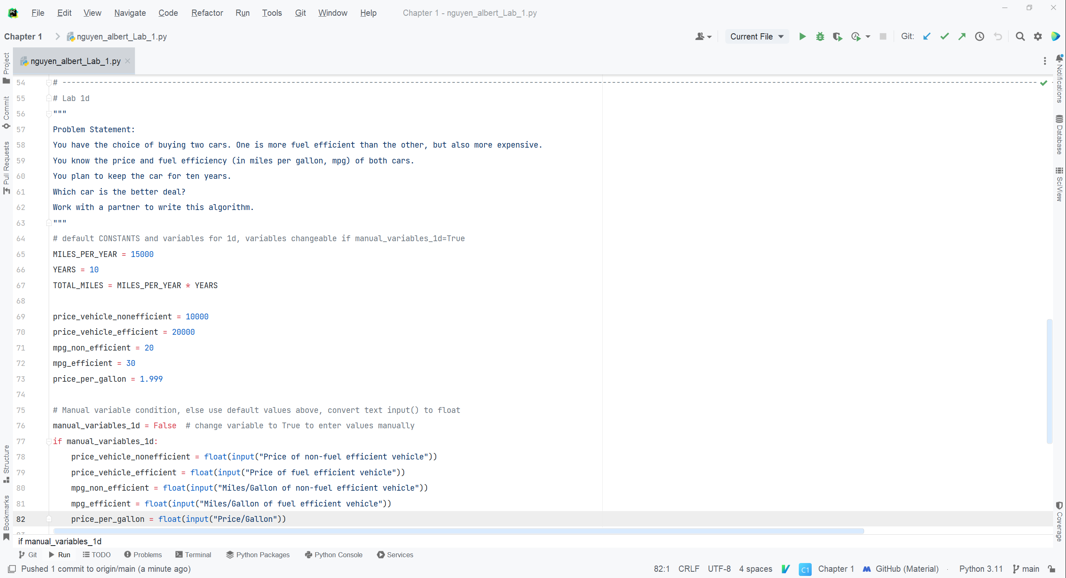

D_Code_p.1

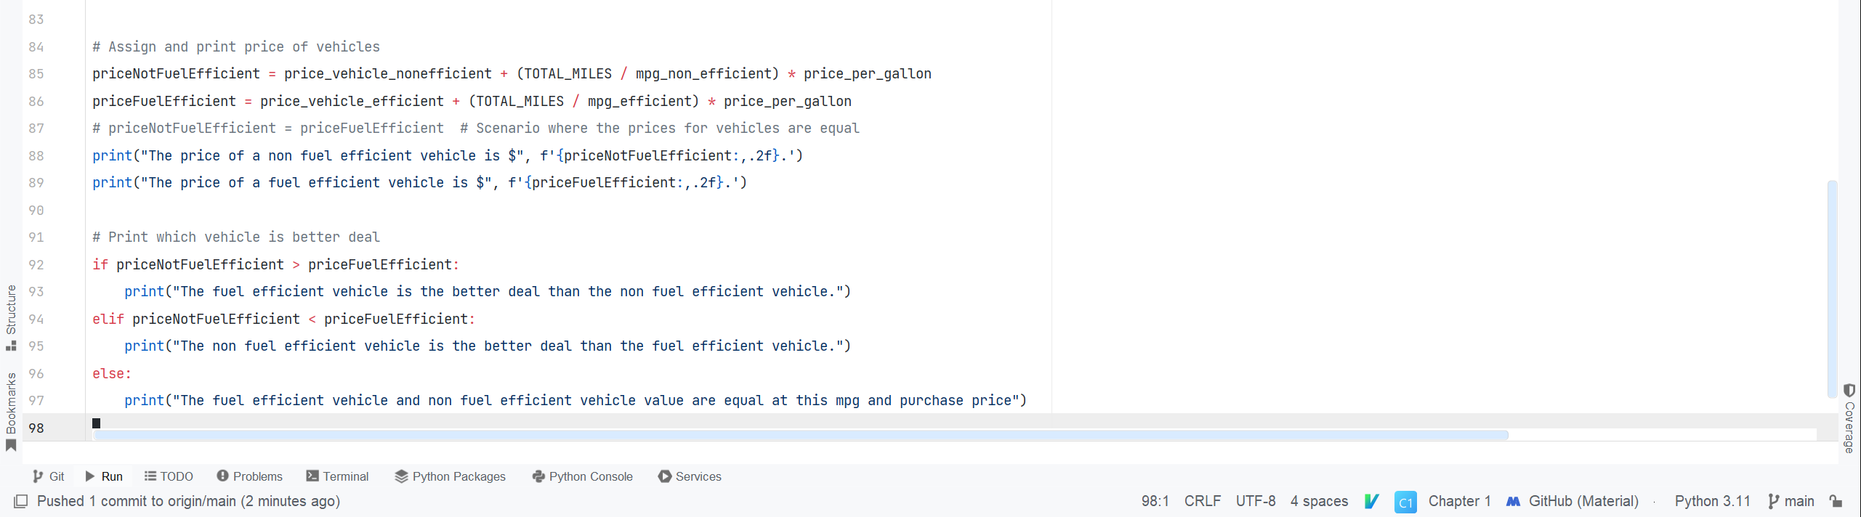

D_Code_p.2

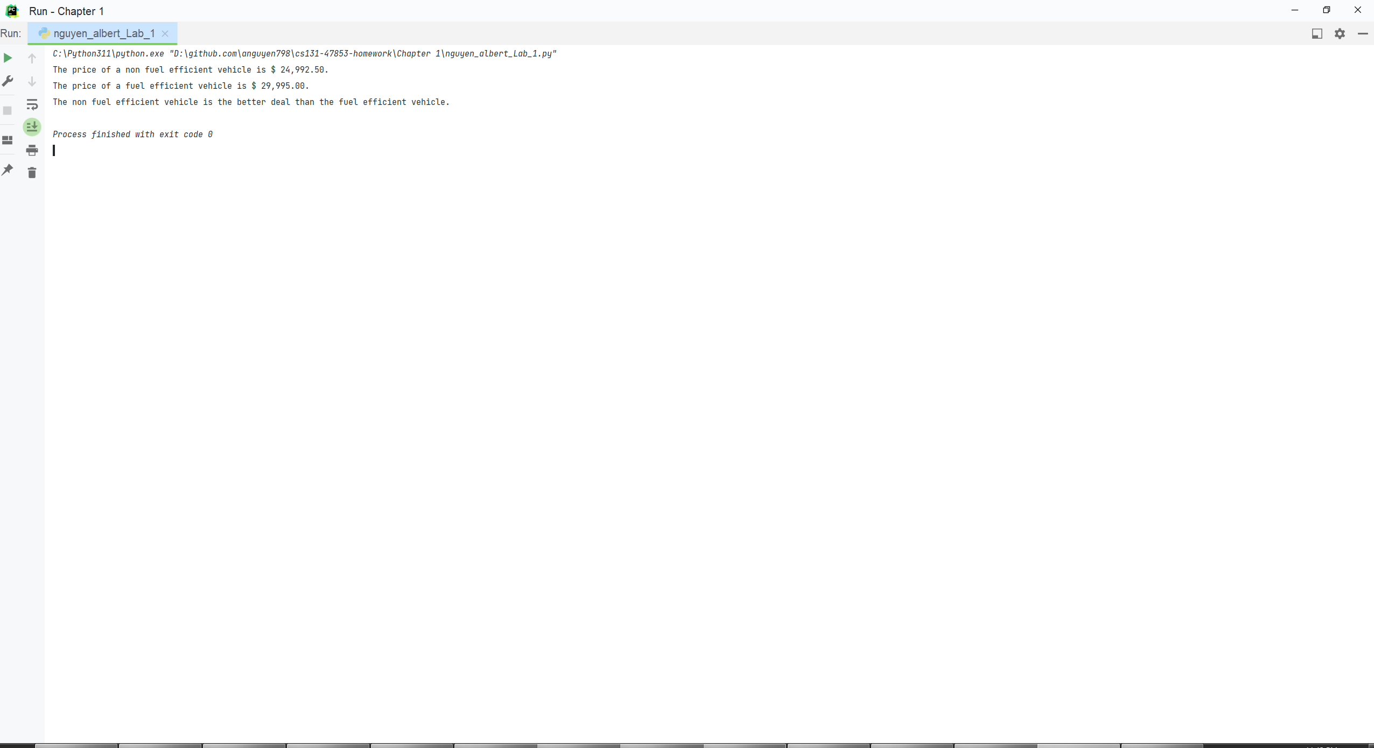

D_Console1

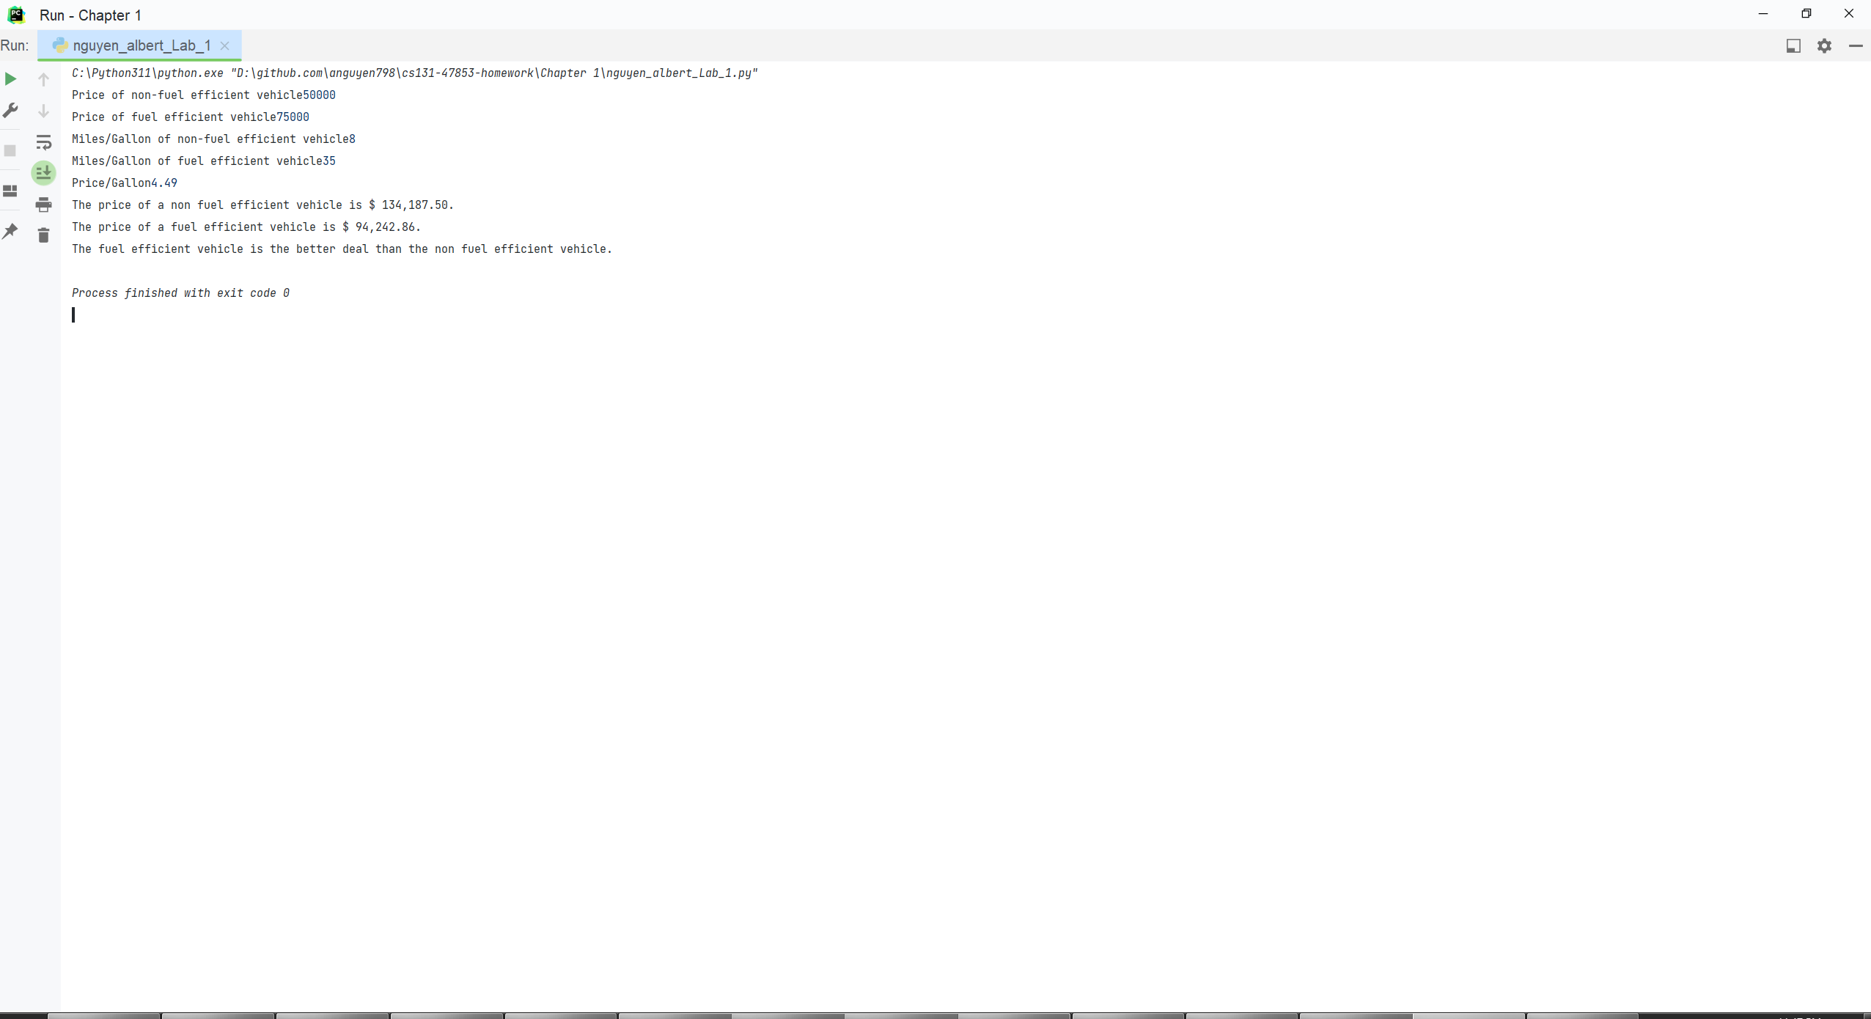

D_Console2

A&B_Code - A – Sample print function in IDE, B – Syntax correction
A&B_Consle - A – Sample print function in IDE, B – Syntax correction
C_Code - Rearranging pseudo-code algorithm
C_Console - Rearranging pseudo-code algorithm – no output due to commented pseudo-code
D_Code_p.1 - Python algorithm for car value
D_Code_p.2 - Python algorithm for car value
D_Console1 - Python algorithm for car value – Default values for variables when manual_variables_1d = False
D_Console2 - Python algorithm for car value – input() values for variables when manual_variables_1d = True

